Problem 1. K-means convergence

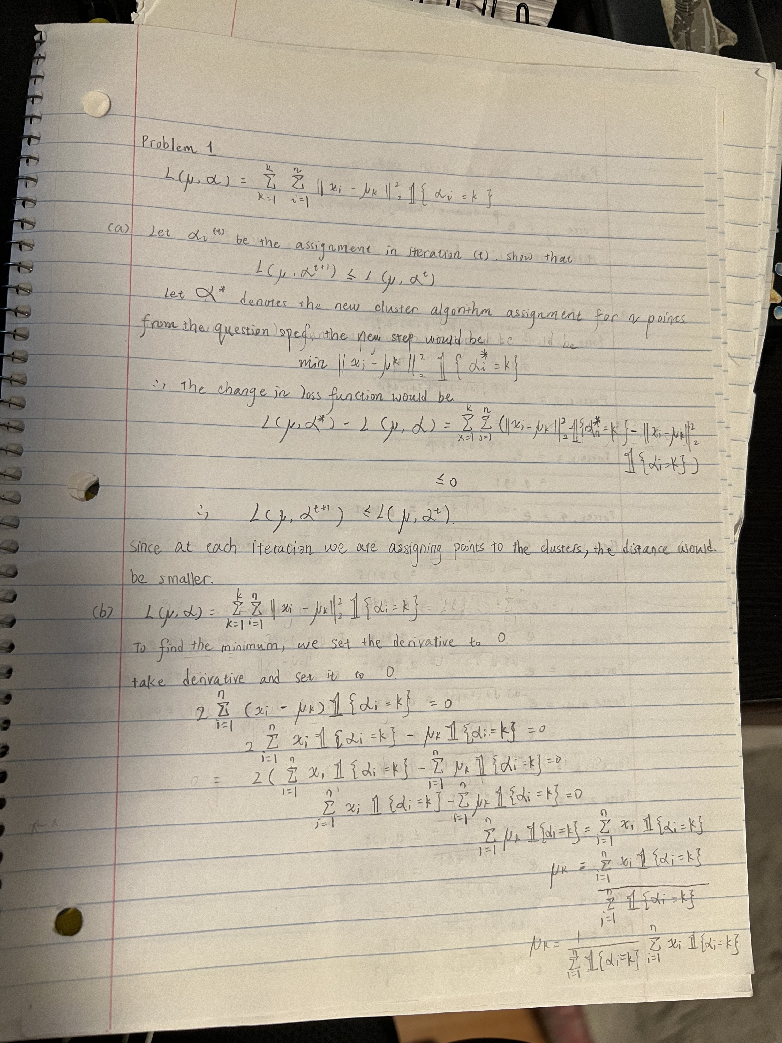

Problem 2. Soft k-means updates

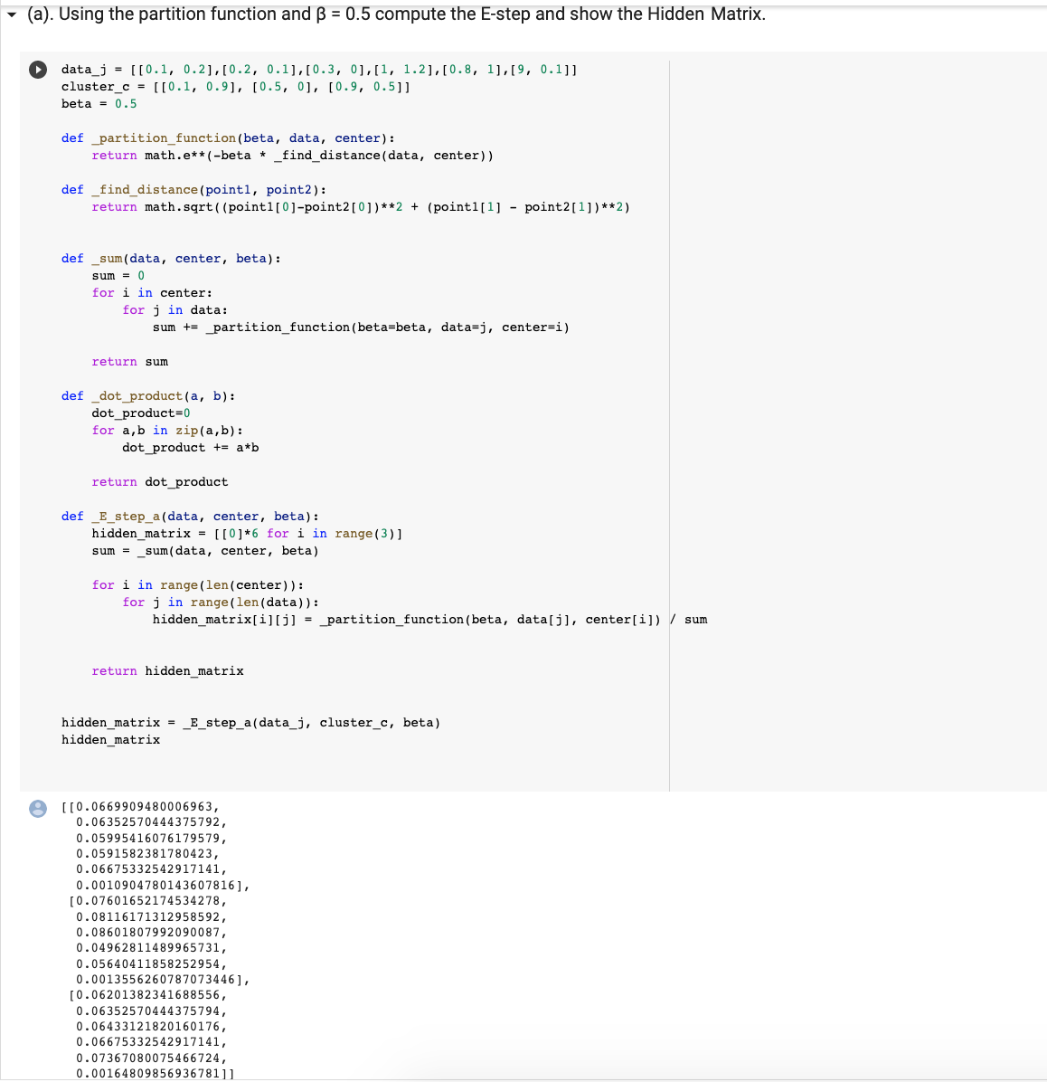

As we can see from the hidden matrix, the first point [0.1, 0.2] would belong to cluster 2, the second point [0.2, 0.1] would belong to cluster 2, the third point [0.3, 0] would belong to cluster 2, the fourth point [1, 1.2] belongs to cluster 3, the fifth point [0.8, 1] belongs to cluster 3, the six point [9, 0.1] belongs to cluster 3.

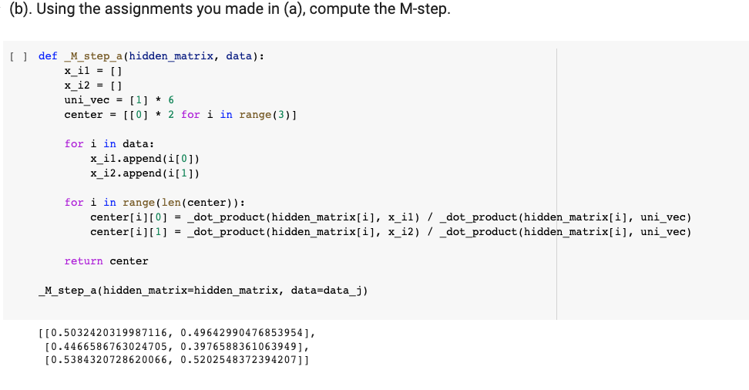

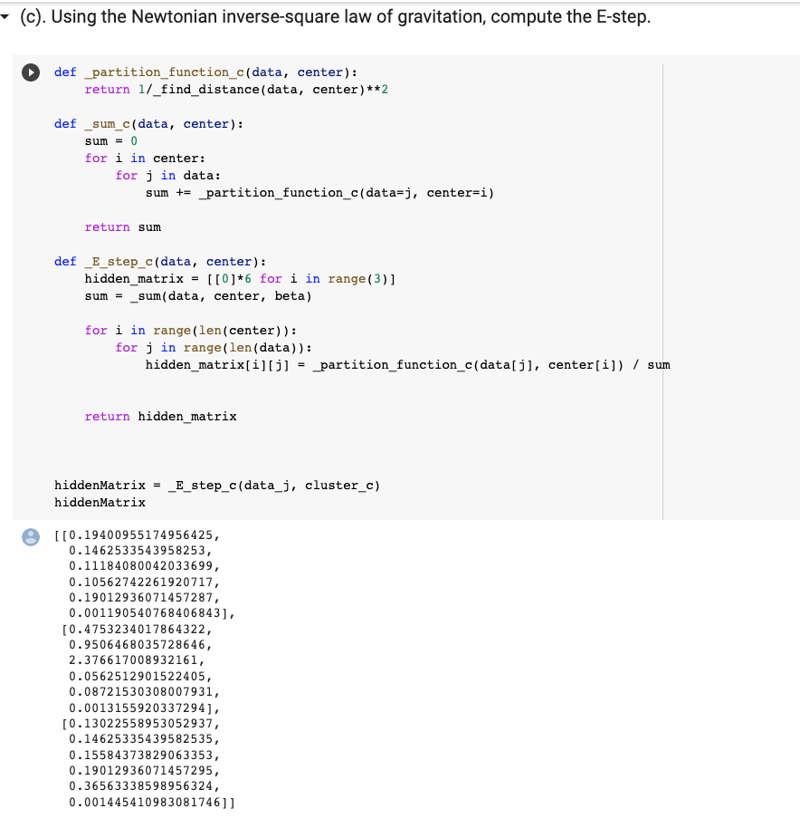

the first point [0.1, 0.2] would belong to cluster 2, the second point [0.2, 0.1] would belong to cluster 2, the third point [0.3, 0] would belong to cluster 2, the fourth point [1, 1.2] belongs to cluster 3, the fifth point [0.8, 1] belongs to cluster 3, the six point [9, 0.1] belongs to cluster 3.

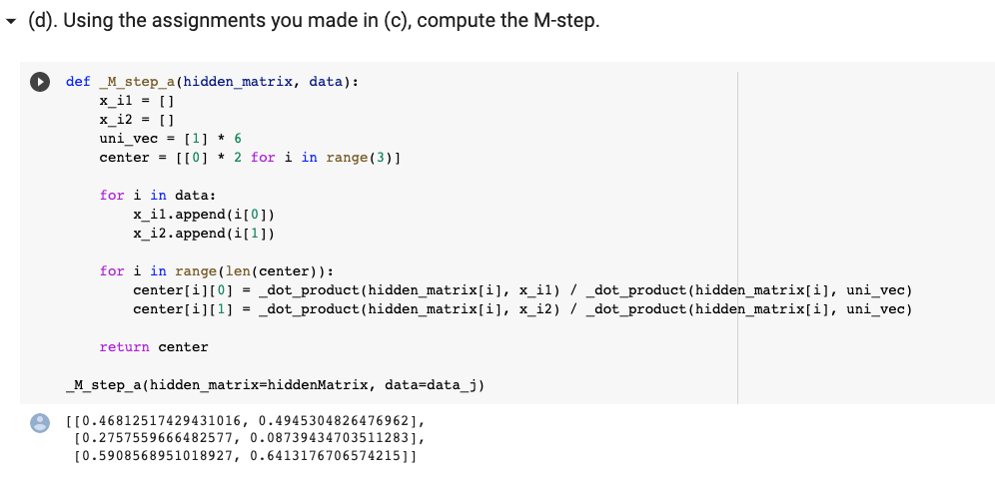

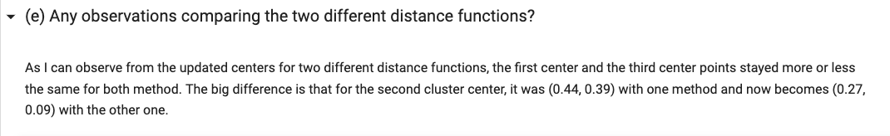

To add to that, the two different distance also assigns the data points to the same clusters.

Problem 3. Decision boundaries in standard k-means

**(a.) Given the current initialization, how are the points assigned using Initialization 1 and**

**Initialization 2? In other words, how does the decision boundary look for each of these**

**initialization in the current assignment step.**

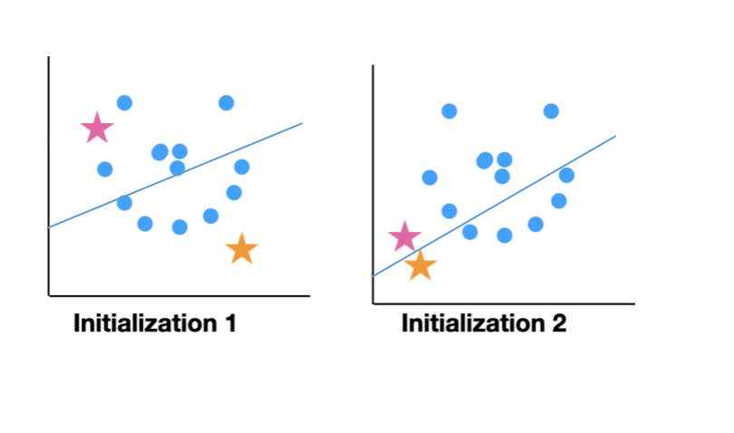

The first initialization has the decision boundary more tilted(the way we defined decision boundary would be any points lies on the decision boundary line would be equidistant from themselves to the centers in all the clusters.) The second initialization has its decision boundary line as a less tilted line.

**(b). Is there a qualitative difference between the assignments in the current step given the**

**different initialization?**

The different initialization will result in different assignments of data points forming different clusters. For example, in this visualizations example, the data belonging to second cluster in initialization 1 could be belonging to the first cluster in initialization 2.

**(c). If you were to run the Lloyd algorithm with both initialization, how would it behave**

**in the long term? Do they converge to the same answer? Does one take longer to**

**converge than the other?**

So the Lloyd algorithm basically randomly selects k numbers of centers, in our case, k=2. Then it assigns each data points closer to a certain centroid and forms a cluster based on that centroid. After this step, each centroid is updated by taking the means of all the data points belonging to the cluster. And just repeat till convergence. Since our centroid is already defined as stars above, in the long run, the centroids would be sitting at the centers of each cluster(since we are repeatedly reassigning the position of each centroid based on the mean). However, just like I mentioned in part b, the algorithm does not necessarily converge to the same answer with different initializated centers. For visualization 1, the clusters could be formed differently as compared to visualization 2. Given the similar data points in each visualization, the convergence time would be similar to each other.

**(d). Do you see a picture in the data?**

A smiley face.

**(e). Draw some clustered data in two dimensions that is trivially easy to cluster by eye,**

**but impossible to cluster correctly using k-means.**

Since k-means always has linear decision boundary, such as a line in 2d and a hyperplane in 3d, there is no way for k-means to separate the clusters below, as the decision boundary will not be linear.

